Submitted by: Pragati Gaire

Student ID: 250195

Git repo: https://github.com/pragatii22/group7_bestest

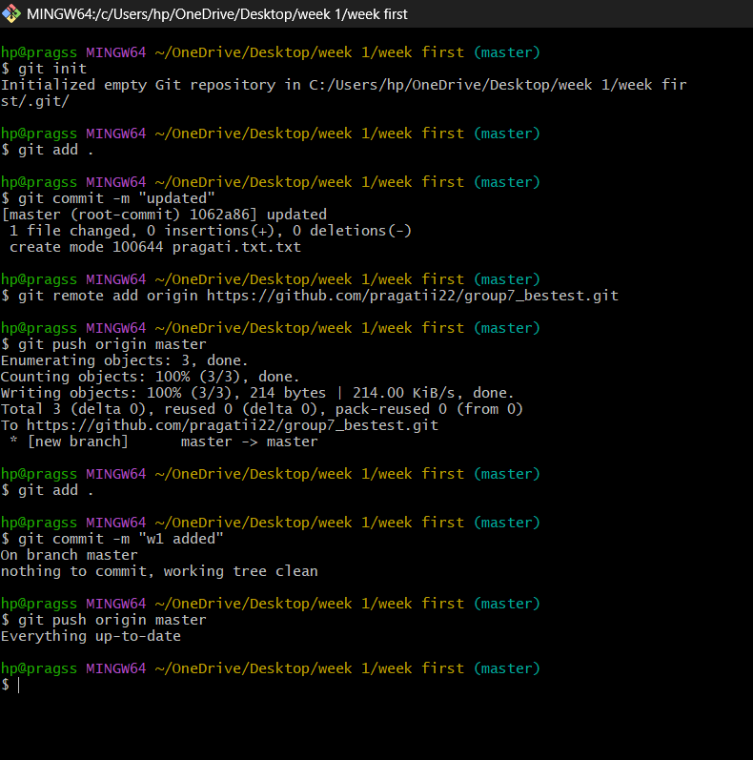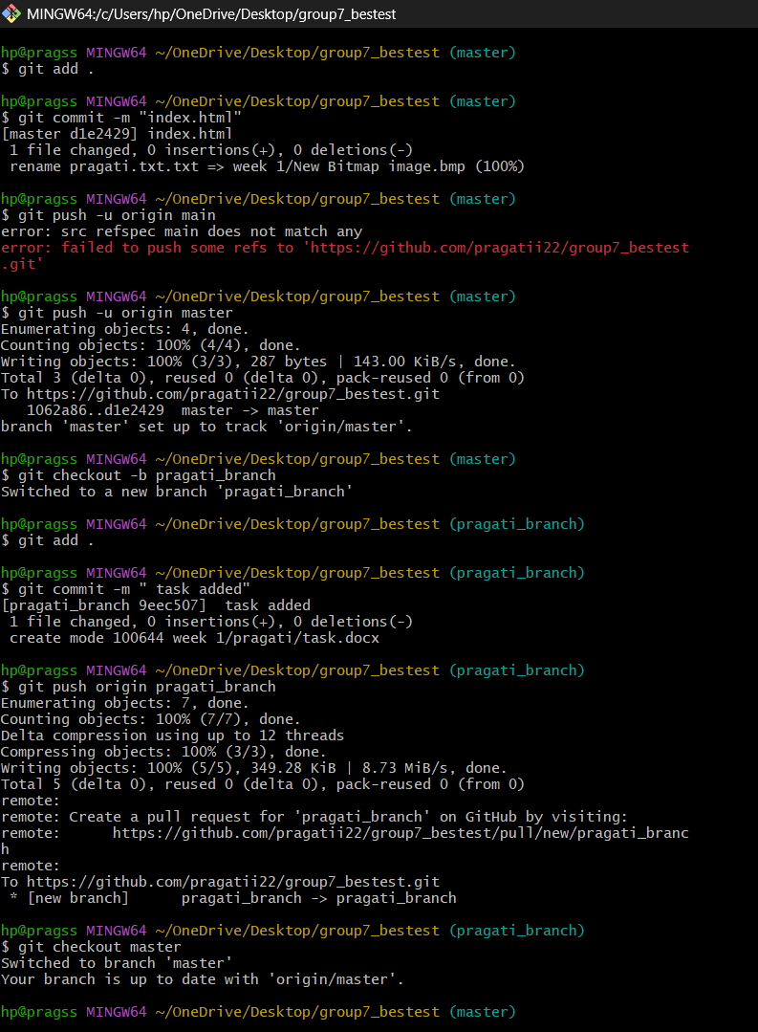

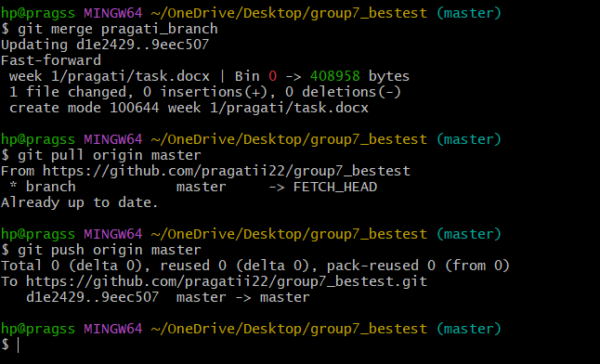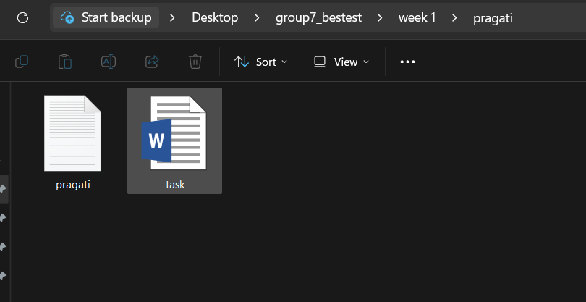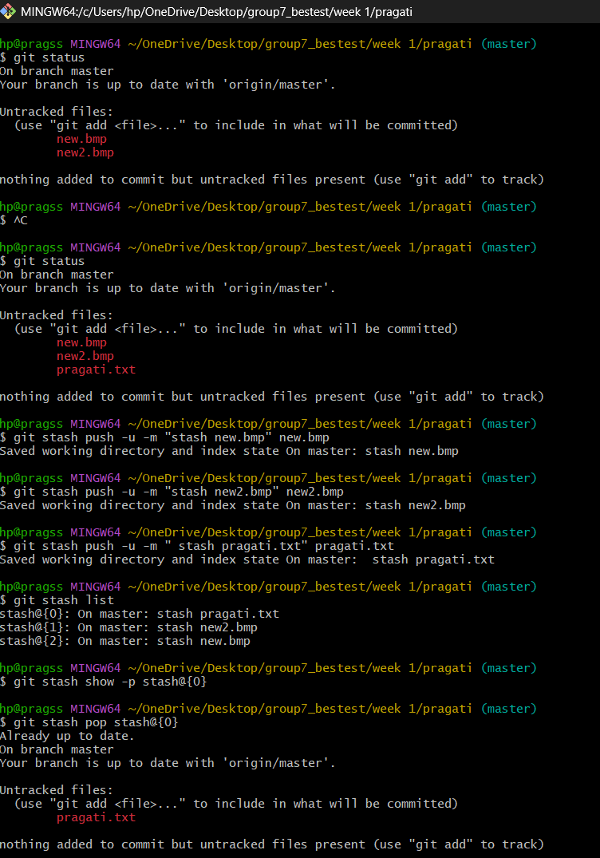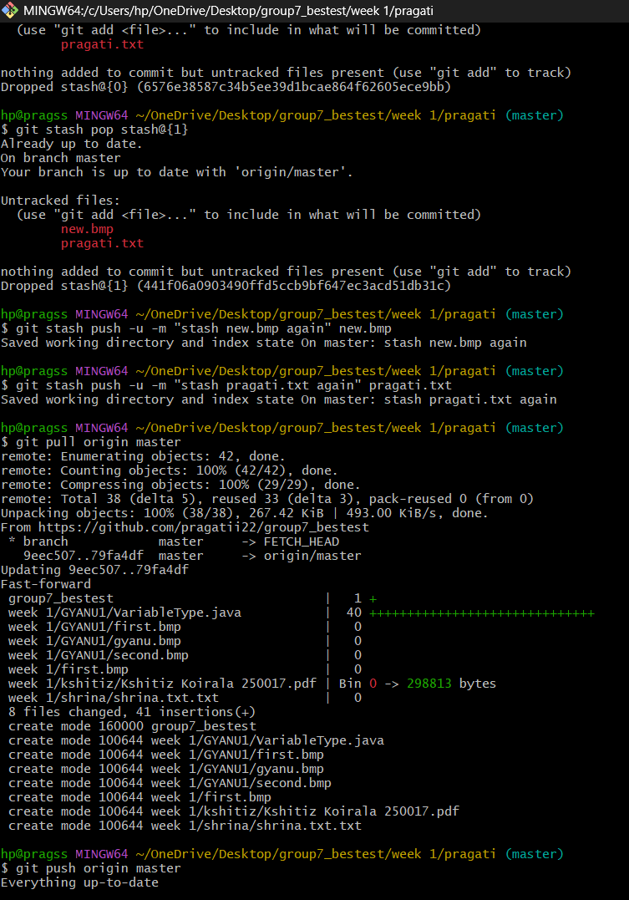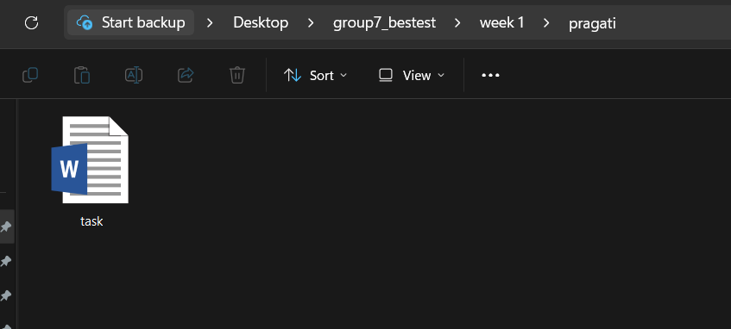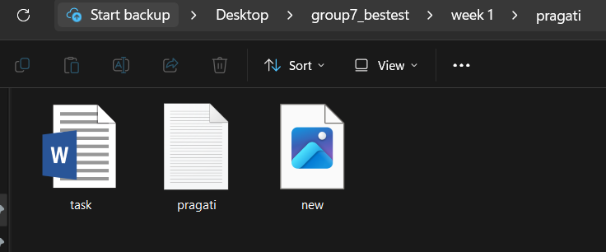

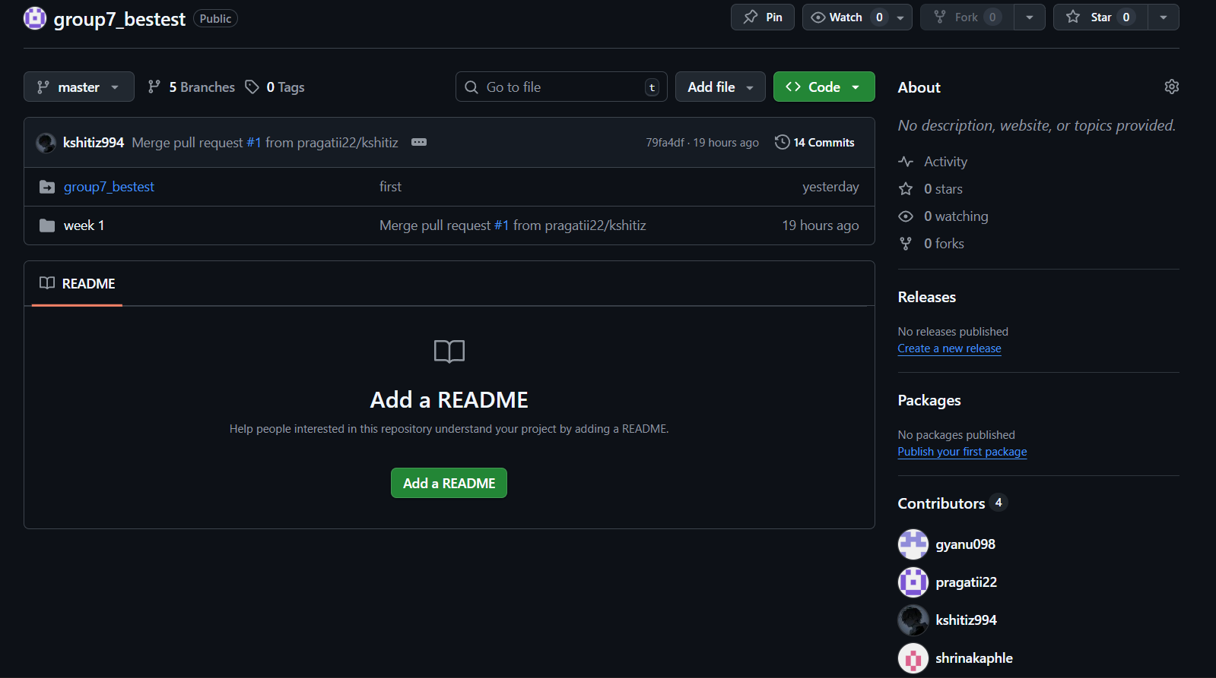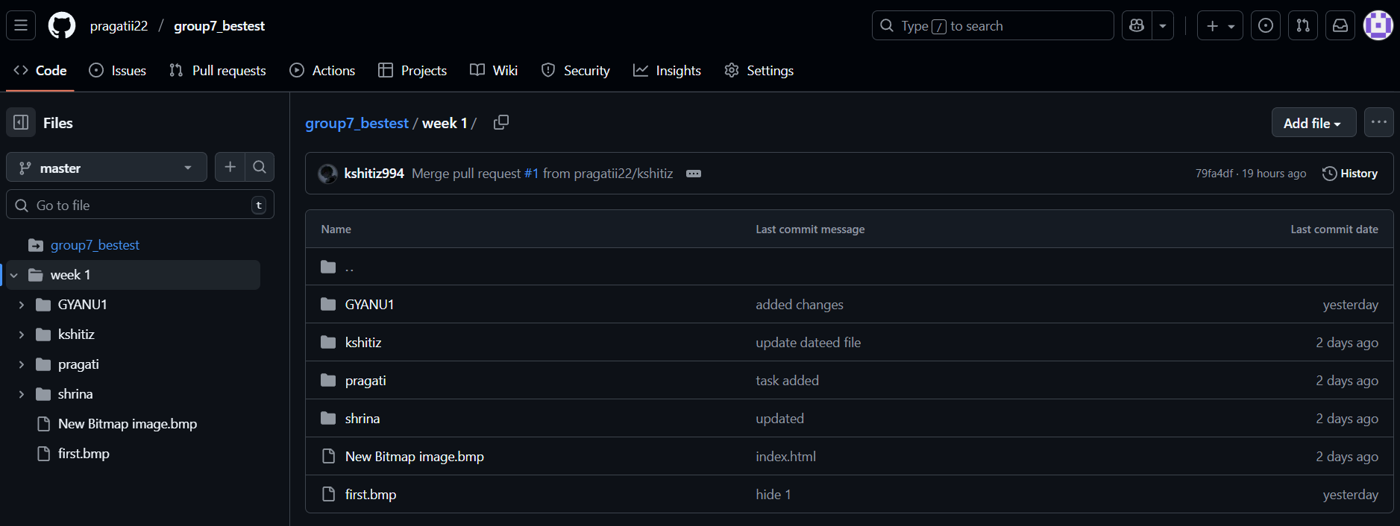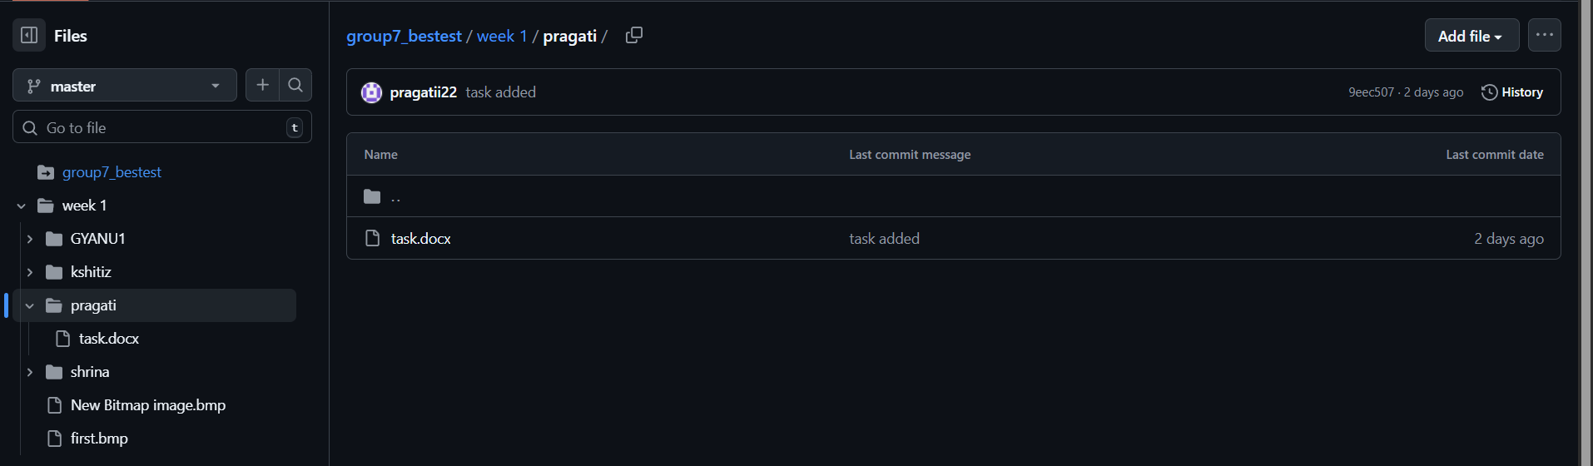

USES OF COMMANDS :

Git push: upload local commits, changes to the remote repository.

Git pull: to fetch and merge the latest updates from the remote repository into the local copy

Git merge: to integrate changes from one branch to another.

Git stash: to temporarily save changes committing them, so the working directory can be cleaned.

Git checkout branch_name: moves to another branch from the current one.

git checkout -b new_branch

Makes a new branch and hops onto it.